*Mrunal D. Pilankar St. Francis Institute of Technology*

**Specification Document for Virtual Key Repositories**

* **Products capabilities**

This prototype provides a quick way of doing file operations through an interface. It supports features to accept the user input to select one of the options listed. The user is guided through the application using appropriate support messages. All files are sorted in the ascending order and any user can add/delete/search a file.

Features:

1. Every business level operation like adding, deleting and searching is provided.
2. Retrieving and displaying files.
3. Appropriate error messages and guidelines are provided for every user action.

* **Product appearance**

1. The product appears in the form of a command line interface with options providing different business level operations like add a file, delete a file, search a file etc.
2. The user is expected to enter choices using the keyboard as input and the output is displayed on the screen.
3. Concise messages and guidelines are given to the user to guide him/her through the interface.

* **User Interactions**

1. The user interface is designed by following the HCI principles.
2. Each user input is supplemented through appropriate user feedback and the flexibility to select multiple options is provided through user-driven menu interface.
3. An appropriate error message is provided on an incorrect input and the user id guided to make a correct choice.
4. Immediate feedback is provided to user on adding and deleting files.

* **Packages and Concepts used**

1. **File Handling and Manipulation**

Java - File Class : Java File class represents the files and directory pathnames in an abstract manner. This class is used for creation of files and directories, file searching, file deletion, etc. The File object represents the actual file/directory on the disk.

The following file manipulation commands are used to implement the different functionalities of the application :

* createNewFile() - The function returns true if the abstract file path does not exist and a new file is created. It returns false if the filename already exists.
* deleteIfExists() – It returns true if the file was deleted by this method; false if the file could not be deleted because it did not exist.
* .listFiles() – This returns the array of abstract pathnames defining the files in the directory denoted by this abstract pathname. File.getName() method is used that returns the Name of the given file object. The function returns a string object which contains the Name of the given file object.
* isFile() – The isFile() function is a part of File class in Java. This function determines whether the is a file or Directory denoted by the abstract filename is File or not. The function returns true if the abstract file path is File else returns false. Parameters: This method does not accept any parameter.

1. **Abstraction using Interfaces**

Abstraction is an OOPs concept which specifies that hide the implementation of object functionality from its utilization and provide an interface to access the functionality.

An interface in Java is a specification of method prototypes. Whenever you need to guide the programmer or, make a contract specifying how the methods and fields of a type should be you can define an interface. To create an object of this type you need to implement this interface, provide a body for all the abstract methods of the interface and obtain the object of the implementing class.

The user who want to use the methods of the interface, he only knows the classes that implement this interface and their methods, information about the implementation is completely hidden from the user, thus achieving 100% abstraction.

I have an interface called LockedMe which is implemented by LockedMeImpl class and provides abstraction by overriding the methods of the interface.

1. **Exception Handling**

Java try and catch

The try statement allows you to define a block of code to be tested for errors while it is being executed. The catch statement allows you to define a block of code to be executed, if an error occurs in the try block. Different types of exception are handled like I/O exception etc are handled.

* **Flowchart of the application**

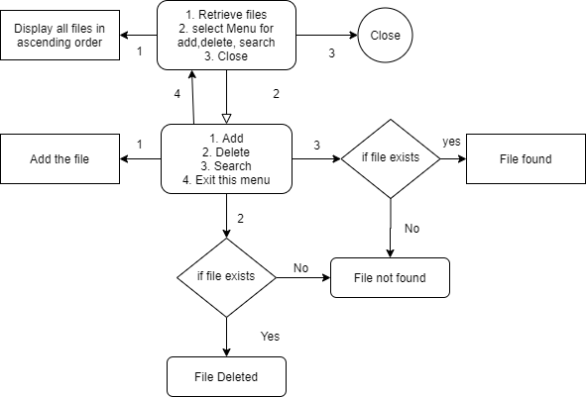

* **Conclusion**

This application can be enhanced by including more file related functionalities like renaming a file or more directory level operations like creating a directory, storing files in directories etc.

Key selling points include:

1. User-friendly navigation and clean interface
2. Easy retrieval of files and easy to perform add, delete, search operations .